**Table of Contents**

1 Introduction 3

1.1 Background 3

1.2 Purpose 3

1.3 Scope 4

1.4 Audience 4

2 Introduction to Clinical Statements 4

2.1.1 Normative HL7 V3 Clinical Statement Definition 4

3 ANF Clinical Statements 5

3.1 Types of ANF Clinical Statements 6

3.1.1 Performance Clinical Statements 7

3.1.2 Request Clinical Statements 7

3.1.3 Precision of Clinical Statements Using ANF 8

3.2 Statement Models 8

4 Clinical Input Form 8

5 Analysis Normal Form 10

5.1 ANF Modeling Principles 10

6 ANF Reference Model 14

6.1 Clinical Statement 14

6.1.1 statementTime 14

6.1.2 statementId 14

6.1.3 subjectOfRecordId 14

6.1.4 statementAuthor 15

6.1.5 subjectOfInformation 15

6.1.6 statementType 15

6.1.7 Topic 15

6.1.8 Circumstance 16

6.1.9 PerformanceCircumstance 19

6.2 Measure and Result 22

6.2.1 Measure 22

6.2.2 lowerBound 22

6.2.3 upperBound 23

6.2.4 includeLowerBound 23

6.2.5 includeUpperBound 23

6.2.6 Resolution 23

6.2.7 measureSemantic 23

6.2.8 InterventionResult 23

6.2.9 ObservationResult 24

6.3 Examples of Performance Clinical Statements 25

6.3.1 Blood Pressure Measurement 25

6.3.2 Pulse Rate Measurement 27

6.3.3 Performance Statement Example 4 27

6.3.4 Performance Statement Example 5 28

6.3.5 Performance Statement Example 6 28

6.3.6 Performance Statement Example 7 28

6.3.7 Performance Statement Example 8 28

6.3.8 Performance Statement Example 9 28

6.3.9 Performance Statement Example 10 29

6.4 Examples of Modeling Request Clinical Statements 30

6.4.1 Request Statement Example 2 31

6.4.2 Request Statement Example 3 31

6.5 Examples of Modeling C-CDA Entries Based on ANF 32

6.5.1 Summary of Care 32

6.5.2 Patient Chart Summary (Excerpt) 35

6.6 Examples of Modeling KNARTs Based on ANF 36

6.6.1 Atrial Fibrillation / Atrial Flutter Order Set (Excerpt) 36

6.6.2 Diagnostic Breast Imaging Documentation Template (Excerpt) 37

7 Transformation 38

8 Differences between ANF and CIF 38

8.1 The Representation of Topic 38

8.2 The Representation of Results 39

**List of Figures**

Figure 1: Architectural Separation of Concerns 11

Figure 2: Clinical Statement 14

Figure 3: Participant 15

Figure 4: Circumstance and Subtypes 16

Figure 5: RequestCircumstance 18

Figure 6: Repetition 19

Figure 7: PerformanceCircumstance 19

Figure 8: UnstructuredCircumstance 20

Figure 9: StatementAssociation 21

Figure 10: Result Hierarchy 22

Figure 11: InterventionResult 24

Figure 12: ObservationResult 24

Figure 13: Topic Comparison for a Complex Topic 32

# Introduction

## Background

The Clinical Information Modeling Initiative (CIMI) is an HL7 group that is defining a library of de- tailed clinical information models using a common modeling formalism. CIMI was established to improve the interoperability of healthcare information systems through shared implementable clinical information models that can be used to generate platform-specific model specifications such as FHIR profiles or CDA templates. These models are grouped into semantically equivalent (or ‘isosemantic’) families of clinical models, which capture the same clinical meaning using different combinations of concept pre-coordination and corresponding information model structure.

**Isosemantic Models**

Ideally, clinical information is modeled in a manner that is most efficient for use. This is a problem because there are many different use cases for clinical information with a wide range of requirements. There is no single model that can be the most efficient model for all the various use cases. Maximum efficiency for each use case necessitates that any particular clinical information be available in multiple modeled forms. These models, although different in form, semantically represent the same information, and are known as isosemantic models. Any particular detailed clinical model exists within a family of isosemantic siblings.

Different isosemantic models can support different purposes, such as clinical data input, clinical data storage, clinical data querying, clinical data analysis, and modeler preference.

Here, we introduce a new isosemantic representation that is designed to aid in the analysis of clinical information and will represent one member in each isosemantic family of detailed clinical models. This representation is called Analysis Normal Form (ANF).

A FHIR implementation guide can eventually be developed.

## Purpose

The purpose of this document is to inform the CIMI community about ANF and why it is needed as an additional standard isosemantic representation of models within CIMI.

**From Ioana:**

I believe the ANF specification can start answer the question: how do we describe a “clinical statement” in a paradigm-neutral way to support clinical decision support and patient safety?

There are tens of examples of **Clinical Statements** in the Consolidated CDA specification that was adopted by all the MU-certified EHR vendors. If we could demonstrate how ANF could be used to encode those clinical statements in an implementation-neutral way and perhaps even how that ANF expression can be used migrate to FHIR, we could provide a potent business case for ANF and Solor.

I see an opportunity to say that the ANF specification provides harmonization across HL7 paradigms and perhaps foreshadow how this ANF specification can help. A work group to address these inconsistencies was established and then merged into Orders and Observation (O&O) Work Group. If we want to present this ballot to the HL7 membership at-large.

## Scope

This document will present the specification of the Analysis Normal Form (ANF), how it is used to create detailed clinical models (DCMs), and how it differs from CIMI's current standard modeling paradigm.

## Audience

The intended audience for this document are all HL7 members.

# Introduction to Clinical Statements

* **Keith’s initial guidance:**
  + Should be written at a higher level for general understanding of the problem
  + Non-technical explanation of issues around clinical content and data analysis
  + Explain, how same piece of clinical data can be recorded in multiple different ways (CIF).
  + Start with simple examples of “Pulse” (Pulse by method, Pulse by patient status) and Blood Pressure (Systolic BP 120 mmHg, taken on right brachial artery), then go into some more complex examples
    - Cite reference study about importance of patient position, micturition etc.

Clinical Statements are used to model all “entries” in a Clinical Document Architecture (CDA) document section. The Clinical Statement “Common Model Element Type” (CMET) is the base model for the all Consolidated CDA “clinical statement” templates that are still mandatory for Electronic Health Record (EHR) vendors. The concept of “clinical statement” is widely understood though there is an issue with consistency across HL7 paradigms: V3, CDA, and FHIR.

Placeholder **HERE** for more detail about other paradigms later in the document (maybe forward link for more detail here)

### Normative HL7 V3 Clinical Statement Definition

“An expression of a discrete item of clinical, clinically-related or public health information that is recorded because of its relevance to the care of a patient or other entity. Clinical or public health information can be expressed with different levels of granularity and therefore the extent and detail conveyed in a single statement may vary. To be regarded as a Clinical Statement, a concept must be associated with a patient or other entity in a manner which makes clear:

* Its temporal context
* Its relationship to the entity or entities
* In the case of an observation, its mood and presence, absence or value
* In the case of a procedure, its mood and status

This clarity may be achieved by:

* Explicit representation; or
* Implicit application of defaults ONLY where explicitly modeled rules state the appropriate defaults."

# ANF Clinical Statements

In the context of the ANF Model, a clinical statement represents an entry in the patient record that documents in a structured/computable manner clinical information related to the patient that is asserted by a particular source, recorded, and potentially verified.

Clinicians author clinical statements and enter them into their organization’s electronic health record (EHR). Clinicians typically enter the information via a manner that we call here the clinical input form (CIF). However, the CIF is not a literal form that clinicians select and enter data in. Rather, it refers to the manner in which information is presented to the clinicians and how they enter the data, such as by constraining the information to allow only certain values to be entered, such as through a drop-down list or radio button, or breaking up large chunks of related information into smaller parts.

**Examples:**

1. Clinicians can measure a patient’s pulse rate by different methods, e.g. by palpation of the radial pulse or by using a doppler ultrasound device. The recording of the pulse rate could be entered in a CIF different Electronic Medical Record (EMR) Systems in different ways.

One EMR could display a set of options to choose from:

* Pulse rate by Palpation
* Pulse rate by Doppler
* Pulse rate by Finger Tip Pulse Oximeter

The clinician would make a choice and then record the measurement result in a text field.

A different EMR could display a text field with a label “Pulse Rate” to enter the measurement result and in addition offer options to choose from to record the method:

* Palpation
* Doppler
* Finger Tip Pulse Oximeter

1. The current guidance for blood pressure measurements for adults includes the body site, the blood pressure cuff size to use as well as some prerequisites. The patient should be in a sitting position for at least 5 minutes and should have urinated no more than 30 minutes before the measurement.

There are different ways the measurement result could be entered into a form in an EMR. Display options for the user could be, e.g. a text field to enter the measurement result (e.g. 120 mmHg) with the label of the complete guideline:

“Arterial blood pressure ____ mmHg, taken on right brachial artery, using adult size blood pressure cuff, patient in sitting position for at least 5 minutes, urinated no more than 30 minutes prior to measurement”. For the user, this would be the easiest way to document the measurement. However, the various parts of information about the body site, the blood pressure cuff, patient position etc. would be lost to any attempt of data retrieval.

A different EMR could display a text field for the result and lists of choices for the body site:

* Right brachial artery
* Left brachial artery

Or:

* Brachial artery
  + - * Right
      * Left

And a list of choices for the blood pressure cuff size used:

* Adult size Small
* Adult size Medium
* Adult size Large

Or other permutations of this.

The same could be true for the display and documentation option for the patient position (sitting yes/no, how long, urinated yes/no, how long prior to measurement), which could differ between systems.

1. When a clinician orders a medication, rather than selecting this information all at once with a single item, they will choose the various parts of the medication order, such as

* Kind of drug and strength (e.g., Acetaminophen 150 mg)
* Amount and how often the patient should take the medication (e.g., 1 tablet twice daily)
  + - Duration (2 days)
* Any constraints (e.g., do not exceed a total daily dosage of 600 mg)

## Types of ANF Clinical Statements

There are two types of ANF clinical statements:

* **Performance of action:** Actions may include passive observation of a phenomenon related to patients and their health status or family history, and may also include active interventions, such as providing education or administering medications or documenting that a patient is participating in exercise to improve their overall health status.
* **Request for action:** Requests for future actions may include defining goals, consultation with other providers, or active interventions.

.

### Performance Clinical Statements

A performance statement describes an action that has previously been performed, and – if applicable - the results of that action. As shown in the examples below, this can range from documenting that a subject of record:

* + - * Was observed to have the presence or absence of a clinical phenomenon
      * Underwent a specific test/screening or procedure, and its resultant value, if any
      * Was administered a medication or other substance
      * Was provided educational materials
      * Has any other state or specific characteristic that is clinically relevant

Examples of performance clinical statements:

1. **Pulse rate of 72/min. taken by palpation of radial artery (resting and exercising)**
2. **Systolic blood pressure of 120 mmHg taken from right brachial artery while seated and no more than 30 minutes after the patient last urinated**
3. Diabetes mellitus is present
4. Diabetes mellitus is not present
5. Three dot blot hemorrhages
6. Dot blot hemorrhage is present
7. Patient taking one Acetaminophen 100 mg tablet by mouth daily as needed for pain
8. Positive screen for fall risk
9. Negative screen for PTSD and depression
10. Family history of colon cancer
11. Patient provided educational materials on pre-diabetes diagnosis
12. Patient counseled on the health risks of continuing smoking

### Request Clinical Statements

A Request clinical statement describes a request for an action made by a clinician. Most of the times, but not always, the object of the request (e.g., lab test, medication order) will be fulfilled by someone other than the clinician (e.g., lab technician, pharmacist) making the request. All information about the request will be documented in this clinical statement, including information about details relating to the request, such as patient must fast for 12 hours before having a lipids blood test.

Examples of Request clinical statements:

1. Lipids panel for patient Jane Doe. Patient must fast for 12 hours prior to the blood test.
2. Head CT with contrast for patient John Doe.
3. Cardiology referral for patient Mary Smith.
4. Penicillin medication for patient Michael Smith to be taken twice a day by mouth with food for 10 days.
5. Advised to participate in group tobacco cessation counseling once a week.
6. Advised to lose 15 pounds within 3 months.
7. Advised to exercise at least 3 times a week for 30 minutes per day for 3 months.
8. Advised to decrease the number of packs smoked per day from 3 to 2 within 6 months by using a nicotine patch.

### Precision of Clinical Statements Using ANF

**From Ioana:**

I think it would be valuable if we could show how ANF can improve the precision of “clinical statements”.

Both C-CDA and FHIR US core specify profiles intended to represent data captured by EHRs. If we could show how an EHR-produced “result” could be represented in ANF.

We could propose this improvement to Orders&Observations, Patient Care, and Clinical Decision Support work groups.

## Statement Models

**PLACEHOLDER**

# Clinical Input Form

* **Keith’s initial Guidance**
  + - Continue the Pulse/BP example here
    - Continue to show, how the different ways of recording data are perfectly normal and acceptable and elaborate on the issues for data retrieval and analysis

Ideally, the way the information is presented to clinicians is in a manner that is most efficient for the clinicians to use. However, what is an efficient way for clinicians to select and enter data may not be the most efficient way for data analysts to use when they are querying data once it has been normalized and stored in a database, such as when creating a new CDS rule or compiling prevalence statistics. For this, the data is normalized using the *Analysis Normal Form (ANF)* and stored in a database. Again, the ANF is not necessarily a physical structure, but is how a data analyst might see the data when they are looking at it in a database, and not as clinicians would see it in the user interface (i.e., CIF).

Clinician collects data ⇨ Clinical Input Form

Data is normalized ⇨ Transformation process from CIF to ANF ⇨ Representable/storable in multiple types of databases

Data analyst who is using or querying the data (e.g., creating a CDS rule or working on prevalence statistics) ⇨ ANF (it is how the data is represented or stored in the database; must know enough about the data to know what is stored in the topic vs. what is stored as a result or detail)

The goal of ANF is to enable analysts to understand the data and how it is stored in lieu of having to teach them about the thousands of ways data can exist within an isosemantic family (i.e., CIF) and ensure the data that has to be expressed can be expressed in an operable and scalable way. The more that data is normalized, the simpler it will become to analyze, and the likelihood of analysis errors will be reduced. Without the ANF, the probability of patient safety risks is increased. Examples of problems that can occur are:

**An inability** to determine that two clinical statements are equivalent

Taking two 250 mg acetaminophen tablets is the same as taking one 500 mg tablet but the analyst only queries for one of the statements, not both.

Presence of dot blot hemorrhage and 2 dot blot hemorrhages observed are equal in regard to presence and absence but the analyst queries only for presence vs. a quantitative finding of dot blot hemorrhages.

**An inability** to express something that is clinically significant

We may not be able to express chest pain on inspiration, which can be a sign of pleurisy. The ability to differentiate cardiac chest pain from other types of chest pain is clinically important. An example of something that needs to be represented is *chest pain that worsens when you breathe, cough, or sneeze*.

**An error is made** in recording or in querying a repository for clinical statements

On October 1, 2016, a provider enters a medication order for acetaminophen 250 mg for a patient to take 1 tablet twice daily for 2 days starting October 1, 2016

CIF: Provider enters the medication order

ANF: Analyst creates a CDS rule to identify all patients ordered acetaminophen during the period September 1 – December 31, 2016. However, while the analyst creates a query to search for a clinical statement (i.e., Request) where acetaminophen was the direct substance and was ordered during the period September 1 – December 31, 2016, the analyst did not include a Request topic of “Administration of drug or medication PO BID for pain.” Thus, the medication order would not be included in the query results.

# Analysis Normal Form

* **Keith’s initial guidance**
  + Goal is to show in examples, how ANF normalizes the data from CIF

## ANF Modeling Principles

* 1. **Separation of Concerns:** As defined by Wikipedia[1]: Separation of Concerns (SoC) is a design principle for separating a computer program into distinct sections, such that each section addresses a separate concern. A concern is a set of information that affects the code of a computer program. A concern can be as general as the details of the hardware the code is being optimized for, or as specific as the name of a class to instantiate. A program that embodies SoC well is called a modular program. Modularity, and hence separation of concerns, is achieved by encapsulating information inside a section of code that has a well-defined interface. Encapsulation is a means of information hiding. Layered designs in information systems are another embodiment of separation of concerns (e.g., presentation layer, business logic layer, data access layer, persistence layer). The value of separation of concerns is simplifying development and maintenance of computer programs. When concerns are well-separated, individual sections can be reused, as well as developed and updated independently. Of special value is the ability to later improve or modify one section of code without having to know the details of the other sections, and without having to make corresponding changes to those sections.

The use of immutable objects (see principle B Immutability below) is a technique that fulfills the Separation of Concerns principle.

Attributes that describe specific semantic concepts should be grouped together into a single class and not be spread across a number of classes. Doing the latter leads to tight coupling between classes. Doing the former leads to better decomposition of a potentially complex domain.

* + - **Example:** Attributes for a Role (e.g., Practitioner) should not be mixed with attributes for an Entity (e.g., Person). This allows a person to assume a number of roles over their lifetime or to function in more than one role.

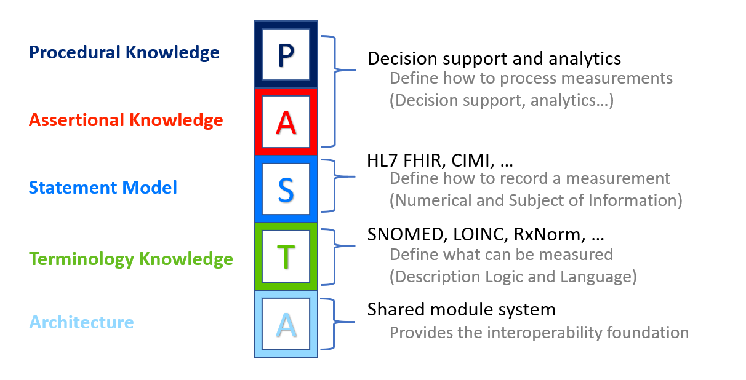

Figure : Architectural Separation of Concerns

Figure 1, “Architectural Separation of Concerns” shows the Statement layer is separate from Terminology layers, yet most CIF statement models mix terminology concerns into the structural attributes of the statement model. ANF attempts to maintain a clean separation between these layers.

The Language and Definitional layers are used to define what is being measured, such as Dot-blot hemorrhage of the retina or Type 1 diabetes.

* 1. **Immutability:** An Immutable Object as defined by Wikipedia[2]: Used in object-oriented and functional programming, an immutable object is something that cannot be changed after it is created, in contrast to mutable objects that can be changed after they are created. There are multiple reasons for using immutable objects, including improved readability and runtime efficiency and higher security.

Although building immutable objects requires a bit more up-front complexity, the downstream simplification forced by this abstraction easily offsets the effort. One of the benefits of switching to a functional mindset is the realization that tests exist to check that changes occur successfully in code. In other words, testing’s real purpose is to validate mutation – and the more mutation you have, the more testing is required to make sure you get it right. If you isolate the places where changes occur by severely restricting mutation, you create a much smaller space for errors to occur and have few plates to test.

Finally, one of the best features of immutable classes is how well they fit into the composition abstraction.

* 1. **Composition Over Inheritance:** Composition over inheritance (or composite reuse principle) in object-oriented programming is the principle that classes should achieve polymorphic behavior and code reuse by their composition (by containing those instances of other classes that implement the desired functionality) rather than inheritance from a base or parent class.

To favor composition over inheritance is a design principle that gives the design higher flexibility. It is more natural to build business-domain classes out of various components than trying to find commonality between them and creating a family tree.

Initial design is simplified by identifying system object behaviors in separate interfaces instead of creating a hierarchical relationship to distribute behaviors among business-domain classes via inheritance. This approach more easily accommodates future requirements changes that would otherwise require a complete restructuring of business-domain classes in the inheritance model.

***Item for Consideration:*** *Should we say that we only allow inheritance for a single concern, i.e., we can subtype measurement but not subtype a combination of statement type and measurement type?*

* 1. **ANF Clinical Statements Represent the Minimum Disjoint Set:** Analysis Normal Form (ANF) clinical statements represent the minimum disjoint set of statement topic, result, and circumstance and may not be further specified.
  2. **ANF Classes Cleanly Separate Concerns:** Analysis Normal Form (ANF) classes must cleanly sepa- rate the concerns of concept definition and the concerns of domain models.
     + ***NOTE:*** *Need to define the domain models thoroughly here.* The strawman description is that domain models use concept definitions as a building block to define non-defining relationships or associations between concepts. The domain model represents cardinality, optionality, and other constraints.
       - **Example:** Laterality should be a concern of either the concept definition or the domain model, but not both. We can relax this principle for the Clinical Input Form (CIF) but for ANF we need a clean and invariant separation of concerns.
     + ***NOTE:*** *Need to determine better names for “concept definition” and “domain models.”*
  3. **Clinical Statement Model Stability:** Stability is different from immutability. Stable means that the model can still meet unanticipated requirements without having to change. It is not acceptable to change the model every time a new way to administer a drug or to treat a condition is identified. By representing these types of potentially dynamic concerns in the terminology expressions, as opposed to static fields in a class structure, we do not have to change the model every time something new is discovered. As Terry Winograd said, anticipating breakdowns, and providing a space for action when they occur, is a design imperative.

In some regards, in this context “stable” means “not brittle.” A model easily broken by changes that someone could anticipate is one possible definition of brittle. A stable model is critical in the phase of a known changing landscape. We do that by isolating areas of anticipated change into a dynamic data structure. That dynamic data structure may also be immutable in an object that represents a clinical statement.

* 1. **Overall Model Simplicity:** In cases where different principles collide, we shall favor the enhancement of simplicity of the entire system over simplicity in one area of the system.
  2. **Cohesion:** Related classes should reside in the same module or construction. The placement of a class in a module should reduce the dependencies between modules.
  3. **Reusability:** Architectural patterns should encourage class reusability where possible. Reusability may further refine encapsulation when composition is considered.
  4. **Assumption-free:** Implied semantics must be surfaced explicitly in the model.
     + **Example:** Implicit in the statement, “I order a book from Amazon” are: paying for the book, delivery of the book to some location, and the transfer of ownership of the book from the vendor to the client.
  5. **Design by Composition and/or Class Specialization:** The capture of additional model expressivity must be captured by composition and/or by class specialization. The modeling approach should avoid the use of design by constraint (except for terminology binding and attribute type constraints) as it violates proper decoupling and encapsulation. An example of design by constraint is to create a single procedure class containing all attributes for all known procedures and constraining out irrelevant at- tributes in a more specialized model. This approach is very difficult to implement and violates numerous object-oriented best practices.
  6. **No False Dichotomies:** Dichotomies that are not completely disjoint (mutually exclusive) lead to arbitrary classification rules and result in ambiguity based on different assumptions about the domain. These must be avoided.
  7. **Model Should Avoid Semantic Overloading (semantic precision):** Semantic overloading occurs when a model attribute’s meaning changes entirely, depending on context. While the refinement of the semantics of an attribute in a subclass is acceptable, a change of meaning is problematic. For instance, in FHIR, the Composition class defines an attribute called Subject. In some subclasses, the attribute may be the entity that this composition refers to (e.g., the patient in a medical record). In other cases, it is the topic being discussed by the composition (e.g., a medication orderable catalog).
  8. **Convention Over Configuration:** Convention over configuration (also known as coding by convention) is a software design paradigm used by software frameworks that attempt to decrease the number of decisions that a developer using the framework is required to make without necessarily losing flexibility.
  9. **Model Consistency:** Patterns should allow the consistent representation of information that is commonly shared across models. For instance, attribution and participation information should be captured consistently. Failure to do so forces implementers to develop heuristics to capture and normalize attribution information that is represented or extended differently in different classes (e.g., FHIR).
  10. **Model Symmetry:** There should be symmetry in the models wherever we can have it.
  11. **Iterative development and validation of model using use cases: TBD**

# ANF Reference Model

The ANF Reference Model is a small static model that can easily be described with UML, OpenEHR BMM, or FHIR StructureDefintion. Detailed Clinical Models are then described as constraints of this reference model. The core of the model is the class ClinicalStatement seen in Figure 2, “ClinicalStatement”.

## Clinical Statement

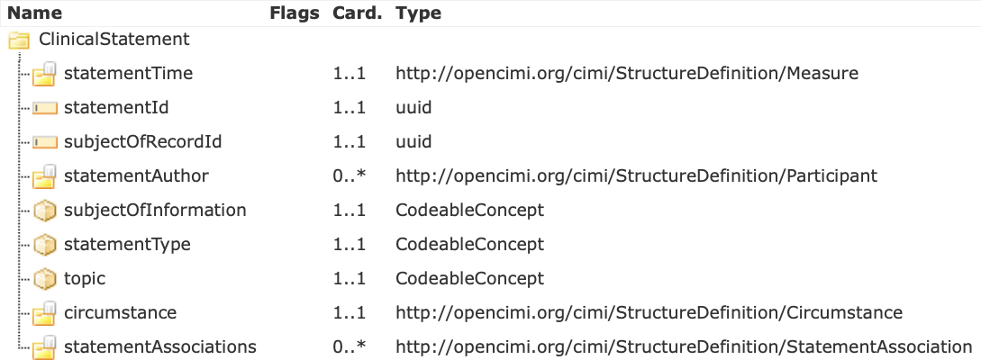

Figure : Clinical Statement

Clinical Statement is the main class which describes an entry of clinical information into the patient record. Most importantly it contains the 'topic' which describes what this statement is about, and the 'circumstance' which will contain either request or result information regarding the 'topic'.

### statementTime

Statement Time describes when the statement was documented in ISO 8601 Date/Time Standard Format

### statementId

Statement Identifier is a unique identifier for the statement represented by a UUID.

### subjectOfRecordId

A patient's clinical record will contain many statements. The subjectOfRecordId is a uuid which identifies the patient clinical record in which this statement is contained. If this statement is in John Doe's patient record, then John Doe is the subject of record and the subjectOfRecordId is a uuid that identifies John Doe.

### statementAuthor

Statement author is an optional list of authoring participants (Figure 3, “Participant”). Either a Participant or its subclass IdentifiedParticipant can be used. Participant includes a coded *participantRole* for values such as 'Healthcare professional', 'Nurse', or 'Requestor'. IdentifiedParticipant adds the additional attribute 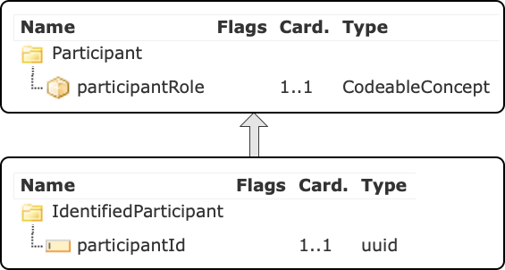*participantId* which is a UUID to uniquely identify the participant.

Figure : Participant

### subjectOfInformation

Subject of Information is a coded field used to express **WHO** the clinical statement is about. A patient's clinical record may contain statements not only about the patient, but also statements about children, relatives and donors. Thus, some possible values for subjectOfInformation, would include codes for 'subject of record' (the patient), 'family member', or 'donor'. The majority of statements will have a subjectOfInformation with a value of 'subject of record', since most statements in a patient record will be about the patient.

### statementType

Statement Type distinguishes between a performance ('performed') and a request ('requested'). Performances may be observational performances, e.g. the observation of a clinical finding or disorder being present or absent. They can also be a procedure or intervention which has been performed on the subject of record in the past, e.g. “a procedure using a 12-lead electrocardiogram”. Performances can – but do not have to – include quantitative or qualitative results, e.g. “3 dot blot hemorrhages” or “Hepatitis A antibody positive”.

### Topic

Topic is the expression of **WHAT** is being requested or what was performed. For both clinical statement types (request or performance) a pre-coordinated or post-coordinated Solor “procedure” concept as a logical expression is required to sufficiently capture the action, which is either requested or performed.

***Requests for actions*** can be requests for actions such as procedures or interventions:

* + - * Stress echocardiogram
      * Administration of Aspirin 81 mg oral tablet
      * Systolic blood pressure measurement

***Performances of actions*** can be performed procedures like the examples above. They can also be observational procedures, describing the absence or presence of clinical findings or disorders. In these cases, the observation action of the clinical findings and disorders is performed:

* + - * Congestive heart failure
      * History of malignant neoplasm of bone
      * Numbness of left arm
      * History of cognitive behavioral therapy

The topic is the central component of clinical statements. The following are proposed principles for the topic of a clinical statement.

**Principle 1:** The topic defines the action being performed or requested.

**Principle 2:** The topic has to be able to exist on its own and still retain original intent and clarity of meaning.

**Principle 3:** The topic includes what is being measured or observed.

**Principle 4:** Each clinical statement may only have one topic.

### Circumstance

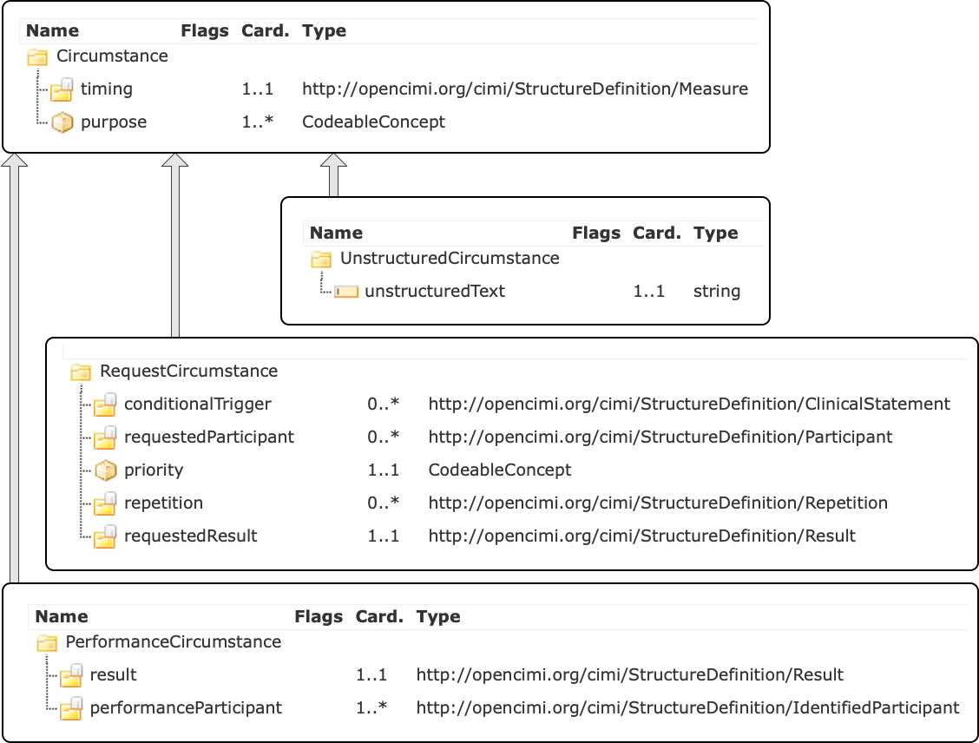

Figure : Circumstance and Subtypes

Circumstances can describe **HOW**, **WHY** and **WHEN** a requested or performed action will be or was carried out.

* + **Principle 1:** Circumstances refine or further qualify the topic.
  + **Principle 2:** Not every request for action or performance of action requires circumstances to be sufficiently defined.
  + **Principle 3:** A circumstance has a key and a value, where the value can be a concept or a numeric range with unit.
  + **Principle 4:** A circumstance can also be given a defining category such as a prerequisite or technique.
* **Prerequisite**:
  + *Definition*: A **state** that **must** exist before something else can happen or be done.
    - The state must exist can prior to the performance of the action
    - The state that must exist pertains to
      * the subject of record (e.g. patient)
      * the environment (e.g. necessary room temperature, required time of day)
    - A prerequisite is separable from the topic and can be expressed as a stand-alone clinical statement
      * Example: Arterial blood pressure 120 mmHg, taken with patient in sitting position. *“Patient in sitting position”* is separable from the topic and exists prior to the performance of the action and therefore constitutes a prerequisite.
* **Technique:**
  + *Definition*: A device used, a method applied, or a temporary state in which the patient was **actively** placed **during** performance of the action.
    - Actions can be performed by various techniques. As opposed to the action itself, which is *what* is carried out, the technique defines *how* the action is done in general or in a particular instance.
    - The use of the device or the method that is applied must start during the performance of the action.
    - A technique is inseparable from the topic and cannot be expressed as a stand-alone clinical statement.
      * Example: Arterial blood pressure 120 mmHg, taken on right brachial artery. *“Taken on right brachial artery”* is inseparable from the topic and cannot be expressed as a stand-alone clinical statement. It therefore constitutes a technique.

Requests and performances have some shared circumstances:

* + - * Timing: **WHEN** a requested action should be performed or **WHEN** an observed finding or disorder was present or absent.
        + Examples:

Cardiology Consult in 2 weeks

Breast cancer screening 3 months ago

* + - * Purpose: **WHY** an action was performed or requested
        + Examples:

Ibuprofen 400 mg oral tables for back pain

Physical therapy 3 times/week for mobilization

Other circumstances are specific to requests or performances.

1. **RequestCircumstance**

Request circumstance further specifies **HOW** a requested action is to be performed, e.g. how often or how long.

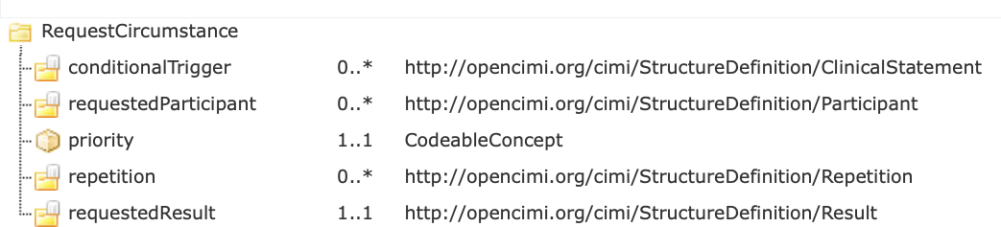

Figure : RequestCircumstance

1. **conditionalTrigger**

TBD

1. **requestedParticipant**

Requested participants is an optional list of either specific persons or roles who perform an action, assist in performing an action or are targets of an action.

Examples:

Cardiology consultation with Chief Cardiologist

Smoking cessation education with patient and patient’s spouse

1. **Priortity**

Priority expresses the priority with which a requested action has to be carried out, e.g. “routine” or “stat”.

1. **Repetition**

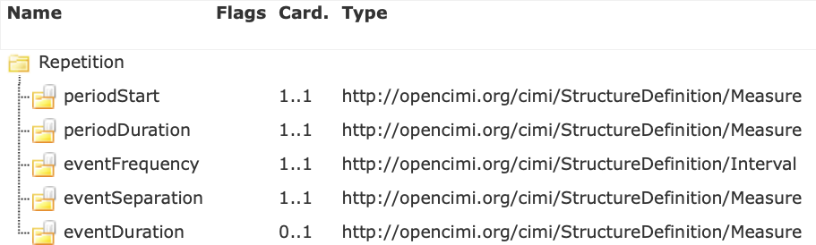

Figure : Repetition

Repetition is used to describe when an action is requested for more than a single occurrence:

When the repeated action should begin (periodStart), e.g. NOW

How long the repetitions should persist (periodDuration), e.g. for 3 weeks

How often the action should occur (eventFrequency), e.g. 3 times per week

How long between actions (eventSeparation), e.g. for 2 weeks

How long every action should last (eventDuration), e.g. for 5 minutes

1. **requestedResult**

A requested result is a patient goal to be achieved. It can include specified or quantified details of an action that is to be performed, such as '3 times daily'.

Examples:

Narrative: Administration of Metoprolol tartrate 50 mg oral daily 2 times to lower systolic blood pressure to <130 mmHg

Narrative: Diltiazem 30 mg, one tablet oral daily 4 times

### PerformanceCircumstance

Performance Circumstance specifies the result of the performance.

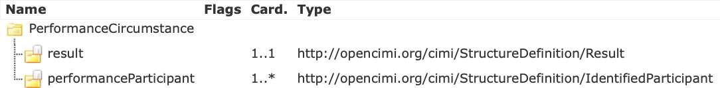

Figure : PerformanceCircumstance

1. **Result**

Result of diagnostic or observational procedures. There are two types of results shown in Figure 10, “Result Hierarchy” which are InterventionResult and ObservationResult.

Examples:

Narrative: Systolic blood pressure 120 mmHg

Narrative: Body weight 165 pounds

1. **performanceParticipant**

Participants involved in performing the action, e.g. technician, nurse

1. **UnstructuredCircumstance**

Unstructured Circumstance is used to document additional parts of clinical statements, which are not necessary for accurate data coding or retrieval.

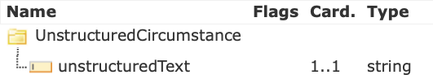

Figure : UnstructuredCircumstance

1. **unstructuredText**

Text field to document unstructured circumstances.

1. **statementAssociation**

Statement associations enable the clinical statement to link to other clinical statements. They are part of the narrative but are not considered part of the topic. They can further specify, e.g. instructions that apply to the performance of an action. If the topic is a laboratory result panel, each association would point to another statement which is a laboratory result.

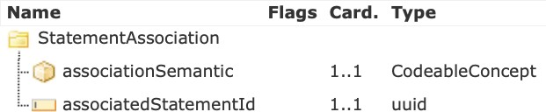

Figure : StatementAssociation

1. **associationSemantic**

Association semantic is a logical expression to capture how the target statement is associated.

1. **associatedStatementId**

Associated Statement Id is a UUID to identify associated statements. This UUID is the statementId of the target ClinicalStatement

## Measure and Result

A unique aspect of the ANF Model is that all measures and results are numeric ranges. The hierarchy of classes to represent these is shown in Figure 10, “Result Hierarchy”. An important point to notice in this class diagram is that the ANF Model does not allow coded results, only a numeric interval is possible.

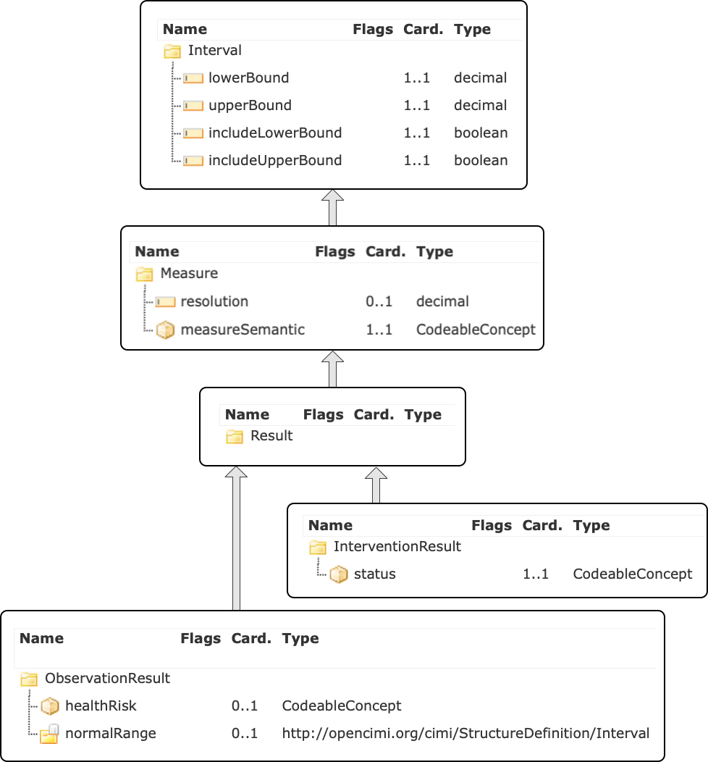

Figure : Result Hierarchy

### Measure

Measure captures measurable elements of clinical statements, e.g. the results of test procedures, time periods, frequencies of repetitions for procedures or medication administrations. Note that the inherited attributes from the Interval class will be discussed here.

### lowerBound

Lower bound represents the lower bound of a measurable element. This can be the lower bound of a range: For the “Administration of 25 to 50 mg of medication X” the lower bound is 25. For a test result, which is not a range, lower and upper bound are the same. Example: systolic blood pressure 110 mmHg. The lower and upper bound are both 110 mmHg.

### upperBound

Upper bound represents the upper bound of a measurable element. This can be the upper boundary of a range: For the “Administration of 25 to 50 mg of medication X” the upper bound is 50 mg. In cases, where the measurable element does not represent a range, upper and lower bound have the same value.

### includeLowerBound

Include lower bound states whether the lower bound in the interval is included in the interval. In the medication examples above, the lower bound would be included. The lower range dose of 25 mg of medication X dose can be administered.

The inclusion or exclusion of lower bound is needed to express measurable elements which include relative properties, such as “greater than”, “less than” and others. Example: “Persistent cough for more than 10 days”. If a lower bound of “10” is chosen, it would not be included, because the example states: more than 10 days. Choosing “11” would require to include the lower bound.

### includeUpperBound

Include upper bound states whether the upper bound in the interval is included in the interval. Similar to lower bound, where the measurable element has relative properties, the same rules apply. If the upper bound of a measure is not defined, e.g. “blood glucose measurement daily for at least 2 weeks”, the upper bound will be captured as “inf” (infinite). Infinite as an upper bound is never included.

### Resolution

The Resolution within a measure defines the possible or allowed increments in which the measured “thing” can be counted. In the example of the systolic blood pressure of 110 mmHg, the resolution is “1”, because the blood pressure measurement result can be counted in 1 mmHg increments. The Resolution is not always defined or known. Example: a clinical statement like “History of breast cancer” implies an undefined amount of time in the past and it is not stated, if it is years, months, etc.

### measureSemantic

Measure semantic represents the unit of measure. It is described using a logical expression. In systolic blood pressure, the unit of measure is millimeters of mercury, and thus the measure semantic is a SNOMED CT concept: 259018001 |Millimeter of mercury (qualifier value). For blood glucose measurement daily for 2 weeks, the measure semantic would be “258705008 |week (qualifier value)”. In cases where the measure pertains to something relative to the statement time, as in the example above of “History of breast cancer” the standardized time/date format ISO 8601 is used for the measure semantic: ISO 8601 prior to statement time.

### InterventionResult

Intervention Result is a result, thus inheriting all the attributes of Result, and adds the attribute *status*, which is a coded value representing the current status of the intervention.

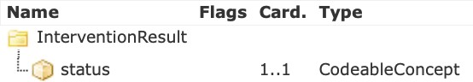

Figure : InterventionResult

### ObservationResult

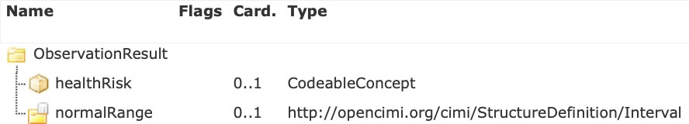Observation Result is a result, thus inheriting all the attributes of Result, and adds the attributes *healthRisk* and *normalRange*. Health Risk is used to flag a result with coded values such as 'low', 'normal', high', and 'critical'. Normal Range is the interval of values that are normal.

Figure : ObservationResult

## Examples of Performance Clinical Statements

For the examples in the following chapters, the focus has been to illustrate the ANF Model, using easy and intuitive examples, rather than focus on the correctness of the modeling. The modeling within the post-coordinated expressions of the “topic” could potentially be done in different ways.

### Blood Pressure Measurement

|  |  |
| --- | --- |
| **Table 1: Performance Clinical Statement** | |
| **Narrative**: ***Arterial blood pressure 120 mmHg; taken on right brachial artery using adult blood pressure cuff;*** patient in sitting position for at least 5 minutes; urinated not more than 30 minutes prior to measurement  Statement type: *[Performance]*  Subject of info: *[410604004 |Subject of record]*  Authors: *[223366009|Healthcare professional]*  Topic: *[5751000205109|Observation procedure]-*  *(260686004|Method) [302199004|Examination - action]-*  *(363702006 |Has focus) [163030003 |On examination - Systolic blood pressure reading]-*  *(405813007 |Procedure site – Direct) [* *723962009 |Structure of right brachial artery]-*  *(424226004 |Using device) [* *720737000 |Blood pressure cuff, adult size];* | |
| Circumstance: | Performance Circumstance |
| Timing: *[ISO 8601 date/time format]*  Purposes: Ø  Triggers: Ø  Participants: *[410604004 |Subject of record]*  Priority: Ø |
| Result: 120 *[259018001 |Millimeter of mercury]* |
| Associations:  fc48551f-876a-42c1-b179-3169e3748332 ***(Table 2: Associated Clinical Statement 1)***  df478857-2eae-40b2-909f-68ef0d0b9eb5 ***(Table 3: Associated Clinical Statement 2)***  Statement time: *[ISO 8601 date/time format]*  Stamp coordinate: *[SOLOR Module]* , *[Release Path]* , 2007-04-05T14:30Z Statement id: a3b46565- f8cd-4354-b4b6-3dff42d33496  Subject of record ID: | |

|  |  |
| --- | --- |
| **Table 2: Associated Clinical Statement 1** | |
| **Narrative**: Arterial blood pressure 120 mmHg; taken on right brachial artery using adult blood pressure cuff; ***patient in sitting position for at least 5 minutes***; urinated not more than 30 minutes prior to measurement  Statement type: *[Performance]*  Subject of info: *[410604004 |Subject of record]*  Authors: *[223366009|Healthcare professional]*  Topic: *[5751000205109|Observation procedure]-*  *(363702006 |Has focus) [33586001|Sitting position finding]* | |
| Circumstance: | Performance Circumstance |
| Timing: ≥ 5 min. prior to statement time  Purposes: Ø  Triggers: Ø  Participants: *[410604004 |Subject of record]*  Priority: Ø |
| Result: 5 *[258701004 |min]* |
| Associations: a3b46565- f8cd-4354-b4b6-3dff42d33496  Statement time: *[ISO 8601 date/time format]*  Stamp coordinate: *[SOLOR Module]* , *[Release Path]* , 2007-04-05T14:30Z  Statement id: fc48551f-876a-42c1-b179-3169e3748332  Subject of record ID: | |

|  |  |
| --- | --- |
| **Table 3: Associated Clinical Statement 2** | |
| **Narrative**: Arterial blood pressure 120 mmHg; taken on right brachial artery using adult blood pressure cuff; patient in sitting position for at least 5 minutes; ***urinated not more than 30 minutes prior to measurement***  Statement type: *[Performance]*  Subject of info: *[410604004 |Subject of record]*  Authors: *[223366009|Healthcare professional]*  Topic: *[5751000205109|Observation procedure]-*  *(363702006 |Has focus) [252041008 |Micturition finding]* | |
| Circumstance: | Performance Circumstance |
| Timing: ≤ 30 min. prior to statement time  Purposes: Ø  Triggers: Ø  Participants: *[410604004 |Subject of record]*  Priority: Ø |
| Result: 30 *[258701004 |min]* |
| Associations: a3b46565- f8cd-4354-b4b6-3dff42d33496  Statement time: *[ISO 8601 date/time format]*  Stamp coordinate: *[SOLOR Module]* , *[Release Path]* , 2007-04-05T14:30Z  Statement id: df478857-2eae-40b2-909f-68ef0d0b9eb5  Subject of record ID: | |

### Pulse Rate Measurement

**PLACEHOLDER**

### Performance Statement Example 4

**Narrative** Patient has thromboembolism history.

**Topic** Observation of thromboembolism.

**Circumstance *Observation Result***

**Value:** [1, inf) ***Timing* Value:** [1, inf)

**measureSemantic:** ISO 8601 prior to statement time

### Performance Statement Example 5

**Narrative** Diabetes Mellitus present.

**Topic** Observation of Diabetes Mellitus.

**Circumstance *Observation Result***

**Value:** [1, inf)

### Performance Statement Example 6

**Narrative** Diabetes Mellitus not present. **Topic** Observation of Diabetes Mellitus. **Circumstance *Observation Result***

**Value:** [0,0]

### Performance Statement Example 7

**Narrative** Three dot blot hemorrhages.

**Topic** Observation of Dot blot hemorrhage.

**Circumstance *Observation Result***

**Value: [3,3]**

**Unit**: count

### Performance Statement Example 8

**Narrative** Dot blot hemorrhage present.

**Topic** Observation of Dot blot hemorrhage.

**Circumstance *Observation Result***

**Value:** [1, inf)

### Performance Statement Example 9

**Narrative** Patient observed to have fall risk.

**Topic** Observation of fall risk.

**Circumstance *Observation Result***

**Value:** [1,1]

**Unit:**count

### Performance Statement Example 10

**Narrative** Family history (mother) of colon cancer.

**Subject of Information** Mother.

**Topic** Observation of colon cancer.

**Circumstance Value:** [1,inf)]

**measureSemantic:** ISO 8601 prior to statement time

## Examples of Modeling Request Clinical Statements

**Medication Order**

|  |  |
| --- | --- |
| **Table 4: Request Clinical Statement** | |
| **Narrative**: ***Ibuprofen 400 mg tablet oral every 6 hours as needed for back pain; may increase dose frequency to one tablet every 4 hours***  Statement type: *[Request]*  Subject of info: *[410604004 |Subject of record]* Authors: *[223366009|Healthcare professional]* Topic: *[71388002|Procedure]-*  *(260686004|Method) [129445006|Administration - action] (363701004|Direct substance) [197805|Ibuprofen 400 MG Oral Tablet]*  *(410675002|Route of administration) [260548002|Oral]* | |
| Circumstance: | Request Circumstance |
| Timing: [2007-04-05T14:30Z, 2007-04-05T15:00Z]±P5M *[ISO 8601]*  Purposes: *[161891005 |Backache]*  Triggers: associate statement backache present  Participants: *[410604004 |Subject of record]*  Priority: *[50811001 |Routine]*  Frequency Lower Bound: 4 *[258702006 |hour]*  Frequency Upper Bound: 6 *[258702006 |hour]* |
| Associations: Ø  Statement time: [2007-04-05T14:30Z, 2007-04-05T15:00Z]±P5M *[ISO 8601]*  Stamp coordinate: *[SOLOR Module]* , *[Release Path]* , 2007-04-05T14:30Z Statement id: a3b46565- f8cd-4354-b4b6-3dff42d33496  Subject of record ID: | |

### Request Statement Example 2

**Narrative** Request for x-ray chest to evaluate chest pain (routine).

**Topic** Performance of Chest x-ray.

**Circumstance Priority:**Routine

**Purpose:**Evaluation; chest pain

### Request Statement Example 3

**Narrative** Request for administration of nitroglycerin 0.4 mg tablet sub-lingual every 5 minutes as needed for chest pain; maximum 3 tablets (routine).

**Topic** Administration of nitroglycerin 0.4 mg tablet sublingual.

**Circumstance *Requested Result***

**Value:** [1,1]

**Resolution:**(1) **measureSemantic:**Sublingual tablet ***Frequency***

Value: [5,15] **Resolution:**5 **measureSemantic:**minute ***Purpose***

Therapeutic; chest pain

**Priority:**Routine

## Examples of Modeling C-CDA Entries Based on ANF

### Summary of Care

|  |  |
| --- | --- |
| **C-CDA Category/Entry** | **Modeling** |
| Reason for referral  Pulmonary Function Tests | **Statement type:** *[Request]*  **Topic:** *[23426006 |Measurement of respiratory function]-*  *(260686004 |Method) [129266000 |Measurement – action]* |
| Allergies, Adverse Reactions and Alerts  Allergen: Penicillin G  Reaction: Hives  Reaction severity: Severe | **Statement type:** *[Performance]*  **Topic:** [*5751000205109|Observation procedure]-*  *(363702006 |Has focus) [294499007 |Allergy to benzylpenicillin]*  ***Associated statement:***  **Statement type:** *[Performance]*  **Topic:** [*5751000205109|Observation procedure]-*  *(363702006 |Has focus) [247472004 |Weal]-*  *(42752001 |Due to) [294499007 |Allergy to benzylpenicillin]-*  *(246112005 |Severity) [24484000 |Severe (severity modifier)]* |
| Problem list   1. Costal Chondritis 2. Asthma | 1. **Statement type:** *[Performance]*   **Topic:** [*5751000205109|Observation procedure]-*  *(363702006 |Has focus) [64109004 |Costal chondritis]*   1. **Statement type:** *[Performance]*   **Topic:** [*5751000205109|Observation procedure]-*  *(363702006 |Has focus) [195967001 |Asthma]* |
| Social History  Never smoked | **Statement type:** *[Performance]*  **Topic:** [*5751000205109|Observation procedure]-*  *(363702006 |Has focus) [266919005 |Never smoked tobacco]* |
| Immunizations  Influenza virus vaccine: completed | **Statement type:** *[Performance]*  **Topic:** [*86198006 |Influenza vaccination]-*  **Result status:** *[255594003 |Complete]* |
| Medications  Albuterol 0.09 mg ACTUAT | **Statement type:** *[Performance]*  **Topic:** [*416118004 |Administration]-*  *(260686004 |Method) [129445006 |Administration – action]-*  *(363701004 |Direct substance) [Rx; 329498 Albuterol 0.09 MG/ACTUAT]* |

|  |  |
| --- | --- |
| **C-CDA Category/Entry** | **Modeling** |
| Functional and Cognitive Status   1. Functional status: No impairment 2. Cognitive status: No impairment | 1. **Statement type:** *[Performance]*   **Topic:** *[5751000205109|Observation procedure]-*  *(363702006 |Has focus) [118228005 |Functional finding]-*  *(363714003 |Interprets) [246464006 |Function]-*  *(363713009 |Has interpretation) [17621005 |Normal];*   1. **Statement type:** *[Performance]*   **Topic:** *[5751000205109|Observation procedure]-*  *(363702006 |Has focus) [373930000 |Cognitive function]-*  *(363714003 |Interprets) [311465003 |Cognitive functions]-*  *(363713009 |Has interpretation) [17621005 |Normal];* |
| Vital signs   1. Height: 70 in 2. Weight: 195 lb. 3. Body Mass Index (calculated): 28 4. BP systolic: 155 mmHg 5. BP diastolic: 92 mmHg | 1. **Statement type:** *[Performance]*   **Topic:** [*14456009 |Measuring height of patient]-*  *(260686004 |Method) [129266000 |Measurement - action]*  **Result:** *70 [258677007 |Inch]*   1. **Statement type:** *[Performance]*   **Topic:** [*39857003 |Weighing patient]-*  *(260686004 |Method) [129266000 |Measurement - action]*  **Result:** *195 [258693003 |pounds]*   1. **Statement type:** *[Performance]*   **Topic:** [*698094009 |Measurement of body mass index]-*  *(260686004 |Method) [129266000 |Measurement - action]*  **Result:** *28*   1. **Statement type:** *[Performance]*   **Topic:** *[5751000205109|Observation procedure]-*  *(260686004|Method) [302199004|Examination - action]-*  *(363702006 |Has focus) [163030003 |On examination - Systolic blood pressure reading];*  **Result:** *155 [259018001 |Millimeter of mercury]* |

|  |  |
| --- | --- |
| **C-CDA Category/Entry** | **Modeling** |
|  | 1. **Statement type:** *[Performance]*   **Topic:** *[5751000205109|Observation procedure]-*  *(260686004|Method) [302199004|Examination - action]-*  *(363702006 |Has focus) [163031004 |On examination - Diastolic blood pressure reading]*  **Circumstance:**  **Result:** *92 [259018001 |Millimeter of mercury]* |
| Results  CO2 27 mmol/L | **Statement type:** *[Performance]*  **Topic:** [*38007001 |Carbon dioxide measurement]*  **Circumstance:**  **Result:** *27 [258813002 |Millimole/liter]* |
| Plan of Care   1. Goal: Weight loss: Patient education: Diet counseling 2. Asthma management: Patient education: Resources and instructions | 1. **Statement type:** *[Performance]*   **Topic:** *[266724001 |Weight-reducing diet education]*   1. **Statement type:** *[Performance]*   **Topic:** *[698605001 |Education about asthma self management]* |

### Patient Chart Summary (Excerpt)

|  |  |
| --- | --- |
| **C-CDA Category/Entry** | **Modeling** |
| Advance Directives  Do not resuscitate | **Statement type:** *[Performance]*  **Topic:** [*5751000205109|Observation procedure]-*  *(363702006 |Has focus) [304253006 |Not for resuscitation]* |
| Allergies, Adverse Reactions and Alerts  Allergen: Penicillin  Reaction: Nausea | **Statement type:** *[Performance]*  **Topic:** [*5751000205109|Observation procedure]-*  *(363702006 |Has focus) [91936005 |Allergy to penicillin]*  ***Associated statement:***  **Statement type:** *[Performance]*  **Topic:** [*5751000205109|Observation procedure]-*  *(363702006 |Has focus) [422587007 |Nausea]-*  *(42752001 |Due to) [91936005 |Allergy to penicillin];* |
| Problem list   1. Chest pain 2. Angina | 1. **Statement type:** *[Performance]*   **Topic:** [*5751000205109|Observation procedure]-*  *(363702006 |Has focus) [29857009 |Chest pain]*   1. **Statement type:** *[Performance]*   **Topic:** [*5751000205109|Observation procedure]-*  *(363702006 |Has focus) [194828000 |Angina]* |
| Social History   1. Former smoker 2. Consumes 12 alcoholic drinks/day | 1. **Statement type:** *[Performance]*   **Topic:** [*5751000205109|Observation procedure]-*  *(363702006 |Has focus) [8517006 |Ex-smoker]*   1. **Statement type:** *[Performance]*   **Topic:** [*5751000205109|Observation procedure]-*  *(363702006 |Has focus) [228319007 |Drinks alcohol daily]-*  *(363714003 |Interprets) [160573003 |Alcohol intake];*  **Result:** 12 [258950000 |Unit/day] |
| Results   1. Hemoglobin 13.2 g/dl 2. Hematocrit 33.5% | 1. **Statement type:** *[Performance]*   **Topic:** [*104718002 |Hemoglobin, free measurement]-*  **Result:** 13.2 *[258795003 |Gram/deciliter]*   1. **Statement type:** *[Performance]*   **Topic:** [*28317006 |Hematocrit determination]-*  **Result:** 33.5 *[118582008 |Percent (property]* |

## Examples of Modeling KNARTs Based on ANF

### Atrial Fibrillation / Atrial Flutter Order Set (Excerpt)

|  |  |
| --- | --- |
| **Orderable Procedure/Narrative** | **Modeling** |
| Referral to cardiology to evaluate atrial fibrillation/atrial flutter | **Statement type:** *[Request]*  **Topic:** [183519002 |Referral to cardiology service]  **Purpose:** *[386053000 |Evaluation procedure]-*  *(363702006 |Has focus) [195080001 |Atrial fibrillation and flutter]* |
| Resting 12-lead electrocardiogram to evaluate arrhythmia | **Statement type:** *[Request]*  **Topic:** [*447113005 |12 lead electrocardiogram at rest]*  **Purpose:** *[386053000 |Evaluation procedure]-*  *(363702006 |Has focus) [698247007 |Cardiac arrhythmia]* |
| Echocardiogram to evaluate left ventricular function | **Statement type:** *[Request]*  **Topic:** [*40701008 |Echocardiography]*  **Purpose:** *[386053000 |Evaluation procedure]-*  *(363702006 |Has focus) [366188009 |Finding of left ventricular function]* |
| X-ray chest to evaluate heart failure STAT | **Statement type:** *[Request]*  **Topic:** [*399208008 |Plain chest X-ray]*  **Purpose:** *[386053000 |Evaluation procedure]-*  *(363702006 |Has focus) [84114007 |Heart failure]*  **Priority:** *[49499008 |Stat]* |
| Basic metabolic panel | **Statement type:** *[Request]*  **Topic:** [*1421000205106 |Basic metabolic panel]* |
| Complete blood count ROUTINE | **Statement type:** *[Request]*  **Topic:** [*26604007 |Complete blood count]*  **Priority:** *[50811001 |Routine]* |

|  |  |
| --- | --- |
| **Orderable Procedure/Narrative** | **Modeling** |
| Metoprolol tartrate 50 mg tablet oral daily 2 times | **Statement type:** *[Request]*  **Topic:** *[416118004 |Administration]-*  *(260686004 |Method) [[129445006 |Administration – action]-*  *(363701004 |Direct substance) [318475005 |Product containing precisely metoprolol tartrate 50 milligram/1 each conventional release oral tablet]-*  *(410675002 |Route of administration) [[260548002 |Oral];*  **Requested Result: 1** *[421026006 |Oral tablet]*  **Frequency: 2** *[258703001 |day]* |

### Diagnostic Breast Imaging Documentation Template (Excerpt)

|  |  |
| --- | --- |
| **Observation/Narrative** | **Modeling** |
| Screening Mammogram | **Statement type:** *[Performance]*  **Topic:** [24623002 |Screening mammography] |
| Mammogram Interpretation Normal | **Statement type:** *[Performance]*  **Topic:** [*370851004 |Evaluation of diagnostic study results]-*  *(363702006 |Has focus) [71651007 |Mammography]*  **Result Status:** *[17621005 |Normal]* |
| Nipple discharge | **Statement type:** *[Performance]*  **Topic:** [*5751000205109|Observation procedure]-*  *(363702006 |Has focus) [54302000 |Discharge from nipple]* |
| Nipple discharge is normal lactation | **Statement type:** *[Performance]*  **Topic:** [*5751000205109|Observation procedure]-*  *(363702006 |Has focus) [54302000 |Discharge from nipple]*  *(42752001 |Due to) [82374005 |Lactation normal]* |
| Breast Skin Changes | **Statement type:** *[Performance]*  **Topic:** [*5751000205109|Observation procedure]-*  *(363702006 |Has focus) [115951000119105 |Breast symptom of change in skin]* |
| First degree relative is a BRCA mutation carrier | **Statement type:** *[Performance]*  **Subject of Information:** *[125678001 |First degree blood relative]*  **Topic:** [*5751000205109|Observation procedure]-*  *(363702006 |Has focus) [445333001 |Breast cancer genetic marker of susceptibility positive]* |

# Transformation

**PLACEHOLDER**

# Differences between ANF and CIF

There are two fundamental differences between the ANF and CIF approach. The first is the representation of topic, and the second is the representation of results.

1. The representation of topic.
2. The representation of results.

## The Representation of Topic

In the ANF model, the topic is represented by a single field containing a simple to complex expression using codeable concepts, whereas in the CIF model, all the pieces of information that make up the topic are broken out and structured as needed into multiple properties with property names and appropriate datatypes.

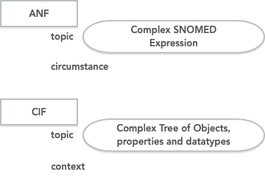

Figure : Topic Comparison for a Complex Topic

One implication of this is that the ANF is using two formalisms to represent the detailed clinical model. First it uses the formalism that represents the ANF reference model and constraints such as HL7's StructureDefinition syntax or OpenEHR's BMM/ADL syntax. Second, it uses SNOMED's syntax for post-co- ordinated SNOMED expressions. Tools for authoring and analysis would be required to parse and process both syntaxes.

The CIF model, on the other hand, would be fully represented using the formalism that represents the CIF reference model and constraints such as HL7's StructureDefinition syntax or OpenEHR's BMM/ADL syntax.

## The Representation of Results

In the CIMI CIF model, EvaluationResult and Assertion models are used to represent results. Evaluation- Result has a topic representing what is being observed, and a result represented by a choice of datatypes.An Assertion on the other hand, has simply a topic with a value of 'assertion', and a result stated what is being asserted.

In the ANF model, the topic represents what is being observed and the result may only be a range of either a count or quantity. No coded results are allowed.

In the CIF model, when creating a model with a numeric result, the choice is quite clear, and the choice will be an EvaluationResult, such as a topic of 'SerumSodium' and result with a numeric quantity. In this case, the CIF and ANF model are very aligned, except for the fact that the ANF model will use a range of that quantity.

But when a CIF model has a potential coded result, the choice between EvaluationResult and Assertion becomes muddied. For example, a model for Breath Sound could be an EvaluationResult with a topic of 'breath sound' and a coded result with the following valueset. Thus, any of the breath sounds within the valueset can act as a result for this model. The other option, is that each of the breath sounds in the valueset is modeled as an Assertion with a topic of 'assertion', and a result of each particular code. To decided which model is better, usually we ponder how the clinician thinks about the data, or how it will be collected, or how it will be queried.

The ANF model cannot do an EvaluationResult style model as it doesn't allow coded results. Thus, ANF is forced to make one and only one choice, which is an assertion style where the particular breath sound is the topic, and the result will be numeric count indicating presence or absence.

* + - Absent
    - Audible
    - Clear
    - Coarse Breath Sounds
    - Coarse Crackles
    - Crackles
    - Diminished
    - Expiratory wheezing
    - Faint
    - Fine Crackles
    - Forced
    - Inspiratory wheezing
    - Left Ventricular Assist Device Noise
    - Markedly Decreased
    - Moderately Decreased
    - Pleural Rub
    - Prolonged Expiration
    - Rhonchi
    - Slightly Decreased
    - Stridor
    - Tubular Breath Sounds
    - Upper Airway Congestion
    - Wheeze

When querying instance data, the Assertion or ANF style is much more difficult for things like breath sounds. To query any breath sound instances, you must have knowledge of all possible breath sound topics and query for each. With the EvaluationResult style, querying is simpler as you simply query for a topic of 'breath sound', and the code result tells you what type of breath sound it is. Thus, you do not have to know all the members of the valueset apriori to form the query. Clinical Statement Examples.

1. https://en.wikipedia.org/wiki/Separation_of_concerns
2. <https://en.wikipedia.org/wiki/immutable_object>